**OKS – Cv.07**

**Zadanie:**

* Generovať 5 tokov - 4 TCP toky (každý 24 p/s) + jeden UDP tok (24 p/s)
* Otestovať rôzne scenáre pre FIFO, CBWFQ, WRED a WRED + ECN

V prvom kroku bolo potrebné nastaviť značkovanie paketov. Pre TCP toky boli použité značky AF11, AF12, AF31, AF33, a pre UDP tok značka AF21. Následne sme tuto politiku aplikovali na rozhranie ktoré prepájalo smerovač s PC (fa0/0).

**Scenár č.1: FIFO**

Tok1 24p/s

Tok2 24p/s

Tok3 24p/s

Tok4 24p/s

Tok5 24p/s

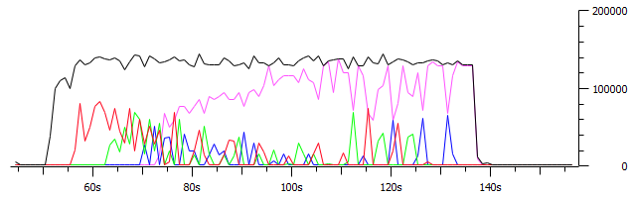

Flow number: 1

Packets dropped = 0 (0.00 %)

----------------------------------------------------------

Flow number: 2

Packets dropped = 0 (0.00 %)

----------------------------------------------------------

Flow number: 3

Packets dropped = 0 (0.00 %)

----------------------------------------------------------

Flow number: 5

Packets dropped = 22 (1.53 %)

----------------------------------------------------------

Flow number: 4

Packets dropped = 0 (0.00 %)

Average loss-burst size = 0.000000 pkt

__________________________________________________________

**************** TOTAL RESULTS ******************

__________________________________________________________

Average bitrate = 118.204166 Kbit/s

Average packet rate = 28.858439 pkt/s

**Packets dropped = 22 (0.89 %)**

Average loss-burst size = 1.222222 pkt

Error lines = 0

**Scenár č.2: WFQ**

Tok1 24p/s

Tok2 24p/s

Tok3 24p/s

Tok4 24p/s

Tok5 24p/s

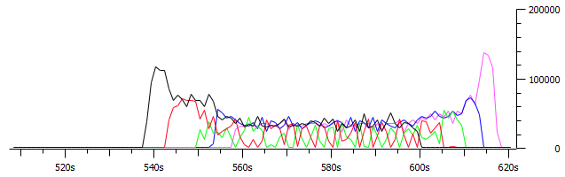

Flow number: 1

Packets dropped = 0 (0.00 %)

----------------------------------------------------------

Flow number: 2

Packets dropped = 0 (0.00 %)

----------------------------------------------------------

Flow number: 3

Packets dropped = 0 (0.00 %)

----------------------------------------------------------

Flow number: 5

Packets dropped = 22 (1.53 %)

----------------------------------------------------------

Flow number: 4

Packets dropped = 0 (0.00 %)

__________________________________________________________

**************** TOTAL RESULTS ******************

________________________________________________________

Average bitrate = 118.204166 Kbit/s

Average packet rate = 28.858439 pkt/s

**Packets dropped = 22 (0.89 %)**

Average loss-burst size = 1.222222 pkt

Error lines = 0

**Scenár č.3: CBWFQ**

Tok1 24p/s

Tok2 24p/s

Tok3 24p/s

Tok4 24p/s

Tok5 24p/s

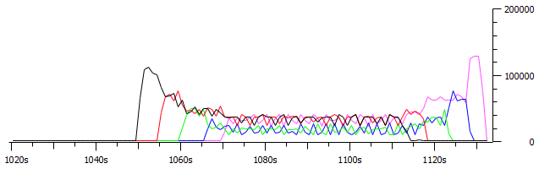

Flow number: 1

Packets dropped = 0 (0.00 %)

----------------------------------------------------------

Flow number: 2

Packets dropped = 0 (0.00 %)

----------------------------------------------------------

----------------------------------------------------------

Flow number: 3

Packets dropped = 0 (0.00 %)

----------------------------------------------------------

Flow number: 5

Packets dropped = 834 (57.92 %)

----------------------------------------------------------

Flow number: 4

Packets dropped = 0 (0.00 %)

__________________________________________________________

**************** TOTAL RESULTS ******************

__________________________________________________________

Average bitrate = 118.143198 Kbit/s

Average packet rate = 28.843554 pkt/s

**Packets dropped = 834 (26.22 %)**

Average loss-burst size = 2.558282 pkt

Error lines = 0

**Scenár č.4: WRED**

Tok1 24p/s

Tok2 24p/s

Tok3 24p/s

Tok4 24p/s

Tok5 24p/s

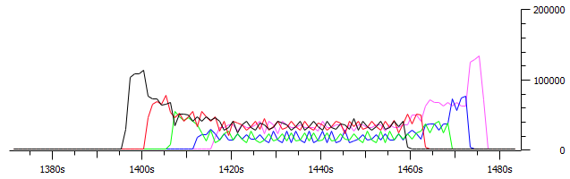

----------------------------------------------------------

Flow number: 1

Packets dropped = 0 (0.00 %)

----------------------------------------------------------

Flow number: 2

Packets dropped = 0 (0.00 %)

----------------------------------------------------------

Flow number: 3

Packets dropped = 0 (0.00 %)

----------------------------------------------------------

Flow number: 5

Packets dropped = 839 (58.26 %)

----------------------------------------------------------

Flow number: 4

Packets dropped = 0 (0.00 %)

__________________________________________________________

**************** TOTAL RESULTS ******************

__________________________________________________________

Average bitrate = 118.193290 Kbit/s

Average packet rate = 28.855784 pkt/s

**Packets dropped = 839 (26.69 %)**

Average loss-burst size = 2.397143 pkt

Error lines = 0

**Scenár č.5: WRED - ECN**

Tok1 24p/s

Tok2 24p/s

Tok3 24p/s

Tok4 24p/s

Tok5 24p/s

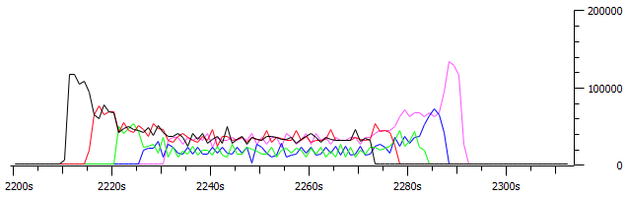

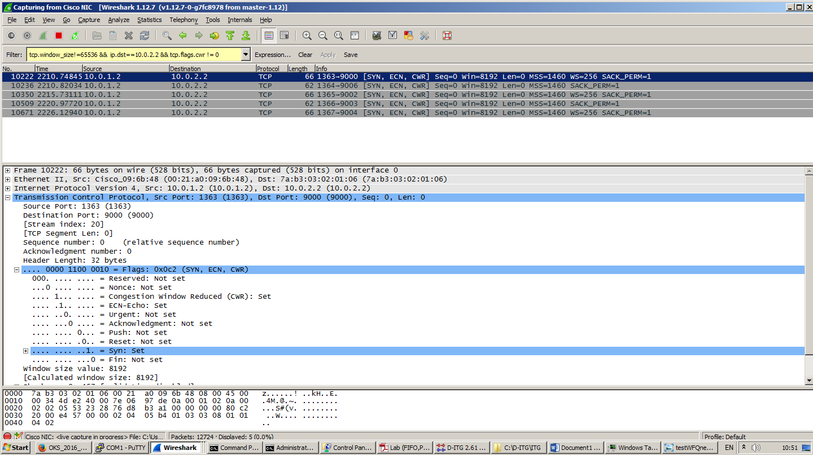

Flow number: 1

Packets dropped = 0 (0.00 %)

----------------------------------------------------------

Flow number: 2

Packets dropped = 0 (0.00 %)

----------------------------------------------------------

Flow number: 3

Packets dropped = 0 (0.00 %)

----------------------------------------------------------

Flow number: 5

Packets dropped = 836 (58.06 %)

----------------------------------------------------------

Flow number: 4

Packets dropped = 0 (0.00 %)

__________________________________________________________

**************** TOTAL RESULTS ******************

__________________________________________________________

Number of flows = 5

Average bitrate = 119.809593 Kbit/s

Average packet rate = 29.250389 pkt/s

**Packets dropped = 836 (26.23 %)**

Average loss-burst size = 2.361582 pkt

Error lines = 0

----------------------------------------------------------